Scanning Work
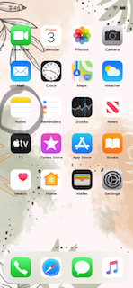

If you have an iphone or ipad work can easily be scanned and sent using the “Notes App.” Begin by opening a new note, then press the camera button and the option to scan document will pop up, you are then able to scan the document. Documents can then be emailed. I would love to see some of the work that students are completing while at home. My email address again is jodi.sobey@nbed.nb.ca.

