Update On Baby Mya
Baby Mya is 8 months old now boys and girls. We didn’t get to spend much time with her though, did we?
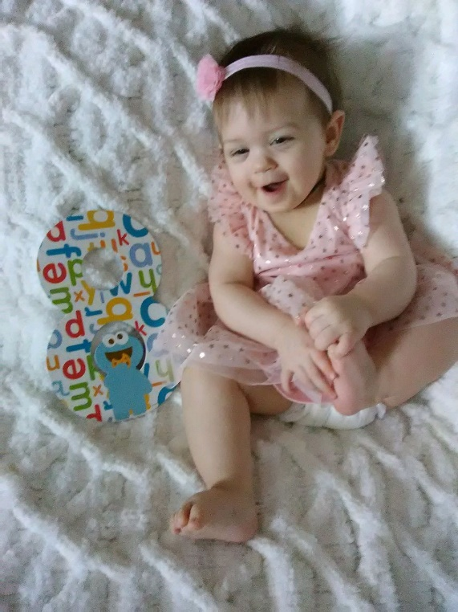

Here is a little update from Mya’s Mom:
Mya is doing great. She has 2 bottom teeth now. She loves to eat baby food and baby cereal. She is a very happy baby, always smiling. She is growing fast, she is wearing size 12 month clothes. She loves her big sister and loves to laugh at her.

