Daily Routine:
Good day, good day, good day to you
Good day, good day, and how do you do?
The sun is/not shining, and the day is new
Good day, good day, and how do you do?
How do you do boys and girls.
Song : Sunday, Monday, Tuesday, Wednesday, Thursday, Friday, Saturday
Now go to Starfall.com and make a calendar. (open for Kindergarten. click on the calendar or look at a calendar at home and talk about it)
Morning Letter
(can you read most of the letter by yourself?)
Dear girls and boys,
Good morning or afternoon .
Today is wonderful Wednesday, June 3, 2020.
Happy Birthday, Connor! He turned 6 yesterday! How can you show 6? (different ways)
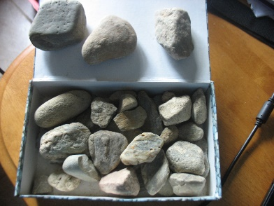
Did you go on a rock hunt?
I found some interesting rocks. LOOK!
We have some wonderful work today!
Have a good day!
Love, Mrs. Craig

Our word of the day is have. Use it for STOP! DROP! and WRITE!
h- plop boing / a- snore prrrsh plop / v- wheee wheee / e- vroom snore (say the letter and strokes out loud)
* Get a paper and pencil ready… set the timer for every 20-30 minutes when it goes off, STOP what you are doing… and write the word for 2 minutes! GO!! (say the letters out loud so they stick to your brain)
Activities for Today:
Language Arts Read –Read- READ!
**Each day, choose an activity (or more) from WEEK 3 on the learning mat posted in the “documents” section.
…Speaking and Listening

Our reading and math theme is Rocks / Stones
Read alouds: - Little Dinosaur https://www.youtube.com/watch?v=IbZIJLEqeFU
Charlotte and the Rock - https://www.youtube.com/watch?v=Zdb6HGtyQfA

***Can you retell one story with a beginning-middle- and end. What was the problem? Did it get solved? How?
*Share the book(s) and talk about them. Ask each other some questions:
*What is the Same and Different about the stories? Which was your favorite? Why?
------------------------------------
I uploaded a list of word wall words> practice a few a day lay a rock or counter for each letter
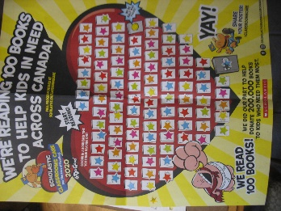
You have read 100 books all together! WOW- we can still help other kids get books if we fill our heart, KEEP READING I will send it to Scholastic ASAP
Check out our class group on Epic
Read books from your “good fit” assigned (go back and re-read for practice with fluency)
You can go to Tumblebooks.com username: nblib password: nbschools for lots of book choices!
**********************************
Writing Model- Write a story about rocks…
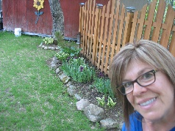
I have rocks in my yard. They go around my flowers.
They are different shapes and sizes.
I have a lot of them.
Tell me more about your story. Add a detail like I did. Use the helper sheets you got in your bag! Before you write, say your story out loud and count the words
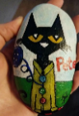 Writing: Think, talk, draw, and write.
Add details to a story you wrote about rocks.
Look closely. Do you have some word wall words?
Did you write the sounds you hear for unknown words
Does it begin with a capital and end with a stop mark?
Can you read it and understand
Did you use your letter making strokes?
--------------------------------------------------------------
Math- Camp Mathematician – See the document for this great math adventure!
Try to build a space rocket using recycled materials around your home? Paper towel rolls, bottles, cans, cardboard… See what you can find and send me a photo… I will post a picture of mine later! Have fun… What 3D shapes can you use? Continue to work on your rocket. Mine is finished!
***Are you able to name the shapes and solids you used? If you have finished, send a picture or maybe a video of you telling me about it -to my email, I would love to see you.
Measurement: Connor told me he thinks he got “taller”. What a great idea to measure ourselves and share our height. Try using non-standard units first (like in the video we saw) then use a measuring tape or ruler. Send in your numbers!!
*continue working on Dreambox aim for 5 activities per week. Make sure to finish each that you begin… Don’t give up…even when it is difficult! Just try your best.
*** try counting back from –8-2, 7-2, 6-2, 5-2, 4-2… GOOD!

Phys. ED and Social/Emotional- Choose activities from WEEK 3 of the activities posted. Get out and play but also take some time to be still.
Cosmic Kids: Zen Den – calm down after a busy day… https://www.youtube.com/watch?v=laDRCHhSTxM
Musicplayonline link is provided on this page. Have fun with the Spring Unit. Play some of the games too!
Today would be You and Your World Day- Here is a story of inclusion and a boy who loved rocks, I hope you enjoy it and talk about the story. Written and read by Sheree Fitch (famous NB poet and author, and a beautiful person)– a true story written after a school visit.
Listen to the Poem Pocketful of Rocks (what might be in your pocket?)
toes in my nose- (pocketful…) https://voiced.ca/podcast_episode_post/ep-03-toes-in-my-nose-and-other-poems/
Here is Pocket Rocks https://voiced.ca/podcast_episode_post/ep-05-pocket-rocks/

