Daily Routine:
Good day, good day, good day to you
Good day, good day, and how do you do?
The sun is/not shining, and the day is new
Good day, good day, and how do you do?
How do you do boys and girls.
Song : Sunday, Monday, Tuesday, Wednesday, Thursday, Friday, Saturday
Now go to Starfall.com and make a calendar. (open for Kindergarten. click on the calendar or look at a calendar at home and talk about it)
Morning Letter
Dear Kids,
Hello Sunshines!
Welcome to a new day of learning.
Today is thinking Thursday June 4, 2020.
It is a _________ day out.
I think that you are wonderful boys and girls.
The classroom is not the same without you.
It makes me sad.
I will be calling you today. Can you think of a story for the class news tomorrow.
What did you do or see this week? What will you do on the weekend?
Have a wonderful day! Love Mrs. Craig

(can you read most of the letter by yourself?)

Our word of the day is out. Use it for STOP! DROP! and WRITE!
o- whoooosh!/ u – yooop! / t –plop! Vroom!
Get a paper and pencil ready… set the timer for every 20-30 minutes when it goes off, STOP what you are doing and write the word for 2 minutes! GO!!

Activities for Today
Language Arts Read –Read- READ!
**Each day, choose an activity (or more) from WEEK 3 on the learning mat posted in the “documents” section.
Read alouds: - Our reading and math theme is Rocks and Stones! This is one of my FAVORITE stories, it makes me think of when I was little like you and all my friends on my street I hope you like it. Can you make a real life connection to this story?
Roxaboxen - https://www.youtube.com/watch?v=-kumeb_Ih2U
I sent a list of word wall words> practice a few a day squat for the word and jump each letter

You have read 100 books all together! WOW- we can still help other kids get books if we fill our heart, KEEP READING
Check out our class group on Epic
Read books from your “good fit” assigned (go back and re-read for practice with fluency)
You can go to Tumblebooks.com username: nblib password: nbschools for lots of book choices!
**********************************
Writing Model- Write a story about rocks… ADD another detail to your story
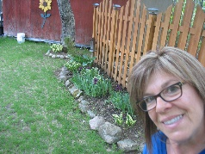
I have rocks in my yard. They go around my flowers.
They are different shapes and sizes.
I have a lot of them.
Some are dark and some are light.

Writing: Think, talk, draw, and write.
Add details to a story you wrote or make a new story!
Look closely. Do you have some word wall words?
Did you write the sounds you hear for unknown words
Does it begin with a capital and end with a stop mark?
Can you read it and understand
Did you use your letter making strokes?
Tell me your story. Use the helper sheets you got in your bag! Before you write, say your story out loud and count the words

Math- Camp Mathematician – See the document for this great math adventure!
*Yoga, Claire’s Camping Adventure - https://www.youtube.com/watch?v=XfamMDftibI
*Continue to work on your 3D model. Thank you for your video,
Are you able to name the shapes and solids you used? If you have finished, send a picture or maybe a video of you telling me about it and what shapes and solids you used -to my email, I would love to see you.
*continue working on Dreambox aim for 5 activities per week. Make sure to finish each that you begin… You are doing some good work! Just try your best.
*** try Counting on From any Number – use a number cube, cards (Ace to 6), your dot cards, or make number cards from 1 to 6. Choose your first number (roll it or pick it from the pile face down) and place that many rocks (or counters) in a familiar way (dice, ten frame) Count out loud as you lay them. Then choose the next number and COUNT ON from your first number arranging them in the same way. (This is an important skill to learn and practice a lot)
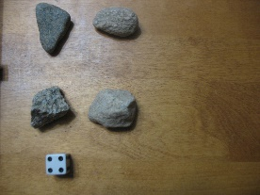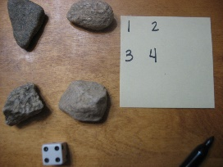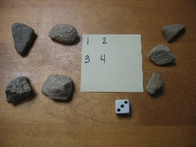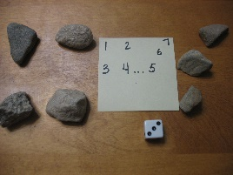

Today would be ART day: here are a couple of fun ideas
Story Stones - https://www.youtube.com/watch?v=fccpritz1lQ
Build an Inukshuk - https://www.youtube.com/watch?v=-DmH8-N-5cs
I would love to see your photos or videos of you trying.

Phys. ED and Social/Emotional- Choose activities from activities posted. Get out and play but also take some time to be still.
Musicplayonline link is provided on this page. Have fun with the Spring Unit. Play some of the games too!

