Home Learning Wrap-Up Choice Board
You Scream, I Scream:  We all Scream for Ice Cream!  Read Aloud: Ice Cream King  https://www.youtube.com/watch?v=hdqc9Cr_Usc  Writing Idea: You’ve been given the important job of creating a new flavor of ice cream.  What would you call it?  What ingredients would be included? | Summer Fun  Read Aloud: And Then Comes Summer  https://www.youtube.com/watch?v=CsV_SzPPN0w  Writing Idea: Summer Bucket List  As you think about summer coming what are some things that you would like to do while on summer vacation. Maybe draw a large sand pail on your paper, inside of it make a list of 5 things you would like to do this summer.
Somewhere Over The Rainbow  Read Aloud: Rainbow Of My Own  https://www.youtube.com/watch?v=QWn7HAxc9p8  Writing Idea: Rainbow Poem  A Rainbow  Is as red as_____________  Is as orange as__________  Is as yellow as __________  Is as green as __________  Is as blue as ___________  Is as purple as __________ | Father’s Day Celebration  Read Aloud: The Night Before Father’s Day  https://www.youtube.com/watch?v=97Y2s7KZhtA  Writing Idea: Trophy For Dad  https://www.youtube.com/watch?v=tXQK-TNatcE  You will begin by learning how to draw a trophy to give to dad. After your drawing is done, how about you write a short story telling your dad why he deserves a trophy.
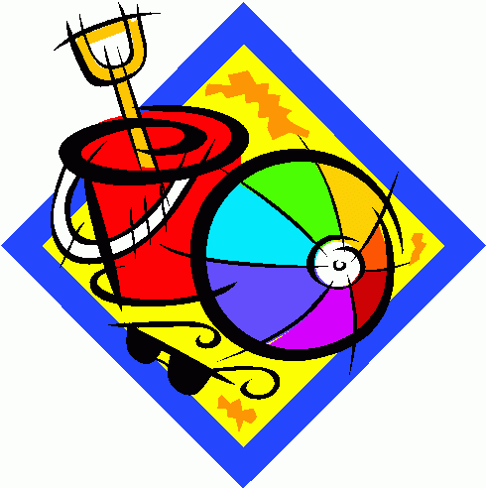
School Year Wrap-Up
Read Aloud: No More Pencil, No More Books, No More Teacher’s Dirty Looks
https://www.youtube.com/watch?v=qGT9ECkQM_M&t=24s
Writing Activity: On the first day of Summer vacation, I am going to…
Suggestions for this final week of Home Learning: Choose 1 activity each day from the board above, read a book independently and complete at least 1 activity on Dreambox. Be sure to also get outside to play and carry out activities that make you smile!

