Math Problem of The Week
May 4th-8th

In Glass A there are 5 pompoms.
How many pompoms do you think are in Glass B?
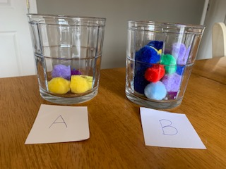
Here is a question to think about that might help!
Do you think there are about 10 in the glass or is the amount closer to 20?
Once you decide on your benchmark (close 10 or close 20) then guess how many?

*You can either email me your estimate or tell me when I call you this week.

