APRIL 6-9
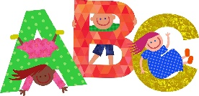 Letters of the week-- Yy and Zz

Words of the week-- got and get

Wednesday at Wear GREEN for Hombolt day
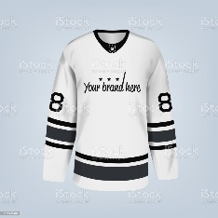 Friday is Hockeyville JERSEY Day.
Let’s step up and help Elsipogtog First Nations win this year!

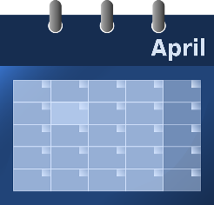 Themes for April – Poetry and Nursery Rhymes, Examining Color, Weather
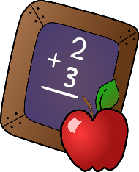MATH- Working on Numeracy Skills
One to one correspondence when counting
Counting begins with 1 and there is a set sequence
The last number said is the amount in the set
The starting point and order of counting does not affect the quantity
The arrangement or types do not affect the count
It doesn’t matter what is being counted, the result will not change

