APRIL 19-23
Letters of the week-- Yy and Zz will finish this week

Words of the week-- this
Our Nursery rhymes – the kids are enjoying sharing their ideas about the nursery rhymes each day. We are having some laughs!
This Little Piggy Read it (Act it out) and then the kids choose an animal and their sound Draw it or find a picture / write it!
Mr. Richardson comes for Guidance each Tuesday
Friday celebrate the Alphabet from Aa - Zz

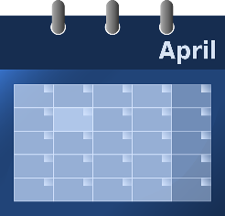
Themes for April – Poetry and Nursery Rhymes, Examining Color, Weather

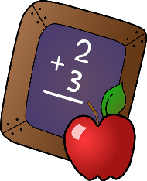
MATH- Working on Numeracy Skills: 1-10
One to one correspondence when counting
Counting begins with 1 and there is a set sequence
The last number said is the amount in the set
The starting point and order of counting does not affect the quantity
The arrangement or types do not affect the count
It does not matter what is being counted, the result will not change

