Language Arts:
Alphabet activities. Find your letters Aa-Ll in the morning letter
Find things around the house that begin with 5 of the letters
Read: Practice some words on your sight word mat
Read Animals In Winter the story – WHO is telling the story to YOU
Is this a story book or an information book? How do you know?
Hibernation https://www.youtube.com/watch?v=eLDbjt_FiTM
Writing- using a dry erase marker (or your finger) trace the letters in your name. Practice 3 other letters too!
Write and send me a story about something that is NOT fun
REMEMBER: THINK, TELL, DRAW, Write (what ever sounds you hear) It’s ok if it is one letter per word, just do your best
Math
Choose a math warm-up from the daily activities sheet.
The number 3- what can you tell me about 5? Who is 5 years old?
Spell it - draw it on a number cube, place 5 items like a number cube, who are it’s neighbors? It is more than ? and less than ? What amounts add up to 5?
5 ___ 3 ____
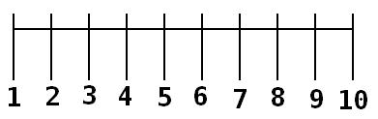

Find some big things around the house and arrange them like the dots on a number cube
Patterns Fun - https://www.abcya.com/games/fuzz_bugs_patterns

FUN FRIDAY!!!!!
Make sure you do something that you find REALLY REALLY REALLY FUN today. (ask your parents to join you, we can all used some FUN! These days)
BUT
Try something new that you think is not fun, but might be… *a new game, *sport, *dance to a new song, or think of something yourself. HEY take a picture of your fun or “not so fun” activity and email it to me! I will post one of myself too. THAT would be fun!
ENJOY

