February 8, 2021 

Dear parents and Guardians

We are now into February, and we have a couple of events coming up. On Friday we will be celebrating Valentine’s Day, with a little party. As always, in the orange phase, students may bring a treat for their classmates but, unfortunately, we cannot share home baked goods. Only individually wrapped store bought items can be accepted. We encourage healthy treats and if you are interested, you may team up for veggie/fruit trays and the like. We have – Bennett, Emma, Haddie, Lanna, Owen, Parker, Russell, River, Will Teachers Mrs. Craig and Mrs. Wormall, Custodian Mr. Paul, Principal Mrs. Hondas,

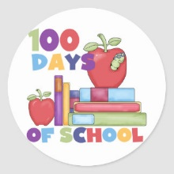

Due to our 2 storm days, the 100th day celebration is now going to be on Thursday the 18 (unless we miss more)… We will have classroom activities organized. If students want to bring a project or display or create a great 100th day T-shirt (most either decorate a 100, or attach 100 items to a t-shirt.



Reminder:

February 24th is Anti – Bullying Pink Shirt Day

We encourage students to wear a pink shirt (if they have one)

All Decked Out has a supply ready if you are interested…