Letters of the week-- Ww and Xx

Words of the week-- went and go

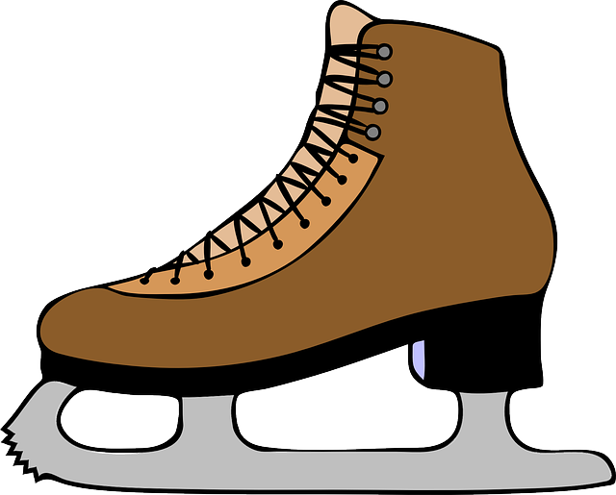 Skating Tuesday at 9:00 a.m.
Picture retakes on Wednesday
Letters of the week-- Ww and Xx

Words of the week-- went and go
Math

