Language Arts:
Alphabet activities. Find your letters a-l in the morning letter
Find things around the house that begin with each letter
Read: Practice some words on your sight word mat
‘Me’ (the little book in your sack) Put your pointer finger UNDER each word (1-1 word match)
Writing- using a dry erase marker (or your finger) trace the letters in your name.
Make a story about you. I am _________ and I like __________
I am Mrs. Craig and I like chocolate! mmmmm
Math
Choose a math warm-up from the daily activities sheet.
The number 4- what can you tell me about 4? Who is 4 years old?
Spell it - draw it on a number cube, place 4 items like a number cube, who are it’s neighbors? Is it more than 5 or less than 5? What amounts add up to 4? What comes in 4’s?
Four ___ 4 ____
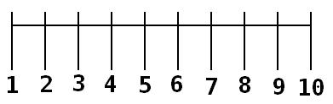

Find some little things around the house and arrange them like the dots on a number cube

Remembrance Day Activities
Listen to the story A Poppy is to remember https://www.youtube.com/watch?v=xes1aUOplBs
Watch the power point included
Begin to color or paint your big poppy do your best coloring.

