Language Arts:
Alphabet activities. Find your letters a-l in the morning letter
Find things around the house that begin with each letter
Read: Practice some words on your sight word mat
Read your Remembrance Day Book… Color your pictures and talk about our freedoms that were fought for us. <3
Writing- using a dry erase marker (or your finger) trace the letters in your name.

Math
Choose a math warm-up from the daily activities sheet.
The number 5- what can you tell me about 5? Who is 5 years old?
Spell it - draw it on a number cube, place 5 items like a number cube, who are it’s neighbors? It is more than ? and less than ? What amounts add up to 5?
Four ___ 5 ____
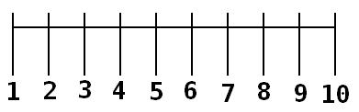

Find some big things around the house and arrange them like the dots on a number cube

Remembrance Day Activities
Listen to the story A Poppy is to remember
Watch the power point included
Finish coloring your big poppy do your best coloring. Cut it out REMEMBER
When I cut-2 thumbs UP! And look at where you want your scissors to go.
Cut out the white cross and stick your poppy to the middle to put in your window for tomorrow.

Online Stories:
Ava’s Poppy https://www.youtube.com/watch?v=rsdjU6ocSBs

