Grade 2 Writing Choice Board
Favorite Animal  What is your favourite animal? Tell me at least 2 reasons why it is your favourite.  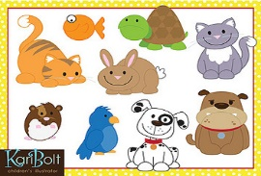  This Photo by Unknown Author is licensed under CC BY | Haha!  What is the funniest thing that has happened to you? Include details! (when, who, what) | Nature Walk  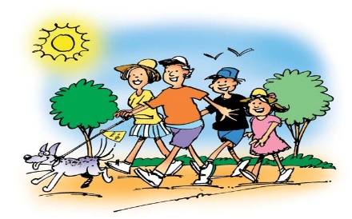  Head outside for a walk with your family. Write about what you see and hear.
Finish The Sentence  Sometimes I wish I could… (tell me why)  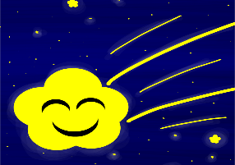  This Photo by Unknown Author is licensed under CC BY | Peace Talk  What does peace look like and sound like?  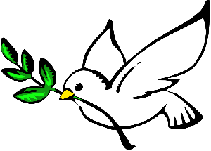  This Photo by Unknown Author is licensed under CC BY-SA | Silly Sentence  Make a list of words that you can think of that rhyme with "all.” Then write a silly sentence using as many of them as you can.  This Photo by Unknown Author is licensed under CC BY-NC
*Choose 1 activity each day to complete. When we return to school I will be looking to see what activities you chose. Also, don’t forget to read one of your Good Fit Books!

