Good Morning Boys and Girls,
Today is the very first day of November.
It was to be Miss. Comeau’s first day with us.
I hope you all had lots of fun Trick or Treating last night.
I didn’t have anyone come visit my house.
For the next few days you will be using your Home Learning packs.
Today I would like you to complete the following tasks:
- Language Arts- Grade 1 & 2
- Reading-Either “Read to Self” or “Read to Someone” one of the books from your Home Learning baggie that we put in your bookbag
- Writing-Complete 1 writing activity from your Home Learning package

- Grade 1 Math
- Practice counting backwards from 20-0 around the circle with your family
- Practice making numbers 0 and 1
- Complete 1 Math Review Activity from your Home Learning package

Grade 2 Math
- Complete 1 Math Sheet from your Home Learning Package

- Head outside for some fresh air and outdoor fun

- Choose one of the following activities:
- Color
- Make a puzzle
- Draw a picture
- Build a creation
- Bake something yummy (with an adult of course )

Have a great day everyone! Love, Mrs. Sobey
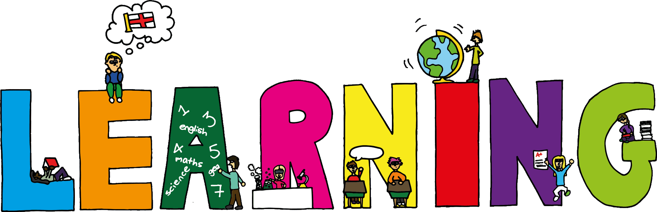
This Photo by Unknown Author is licensed under CC BY

