Tuesday, November 2nd

Today I would like you to complete the following tasks:

- Language Arts- Grade 1 & 2
- Reading-Either “Read to Self” or “Read to Someone” one of the books from your Home Learning baggie that we put in your bookbag
- Writing-Complete a writing activity from your Home Learning package

- Grade 1 Math
- Practice subitizing with J. Hartmann (looking and telling how many without counting)
https://www.youtube.com/watch?v=nKO0yQgJAho
- Practice making numerals 2 and 3
- Complete a Math Activity from your Home Learning package

Grade 2 Math
- See Mrs. Newman’s teacher page for your assignment.

- Head outside for some fresh air and outdoor fun

- Choose one of the following activities:
- Color
- Make a puzzle
- Draw a picture
- Build a creation
- Bake something yummy (with an adult of course )

Have a great day everyone! Love, Mrs. Sobey
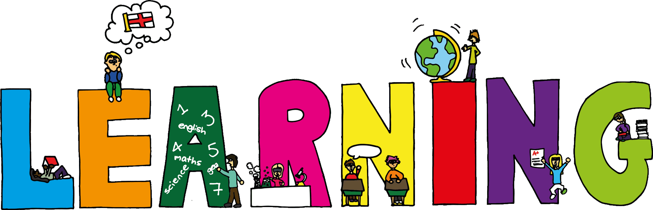
This Photo by Unknown Author is licensed under CC BY

