Grade 2 Writing Choice Board
What would you rather?  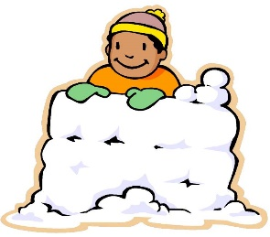  Would you rather build a giant snow fort or have a snowball fight? Why? | Reading Response  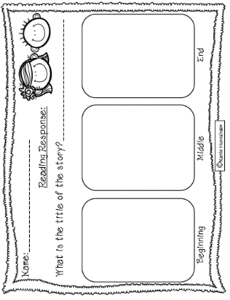  Choose one of your “Good Fit Books” to complete this activity. Write about what happened in your book. | Christmas Gifts!  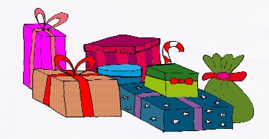  The best gift I received was… (* Include details: who gave it to you, why do you like it best)  This Photo by Unknown Author is licensed under CC BY-SA
Holiday Highlights!  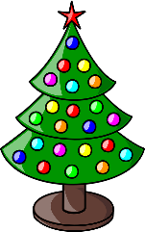  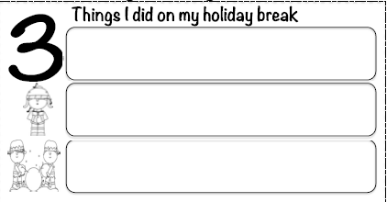 | Happy New Year!  On New Year’s Eve, I… (* Don’t forget to add details: who, what, where )  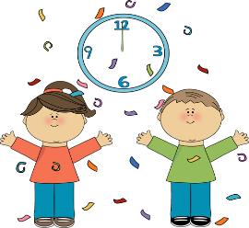  This Photo by Unknown Author is licensed under CC BY-SA-NC | Finish The Sentence  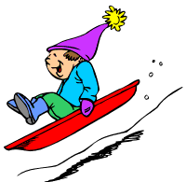  If I had a magic sled I would… (Include some details please. )
*Choose 1 writing activity each day to complete. Once you’ve completed your writing piece, edit your work using the Writing Checklist. When we return to school, I will be looking to see what activities you chose. Also, don’t forget to read one of your Good Fit Books!

