Grade 1 Math Choice Board
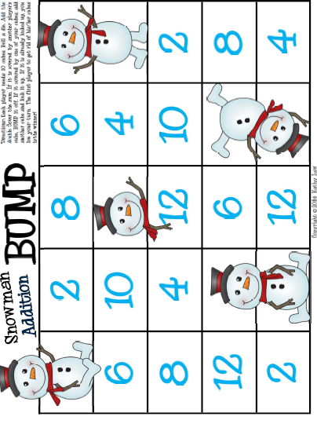  Snowman Bump!  *Game will be included in learning pack. | Friends of 10  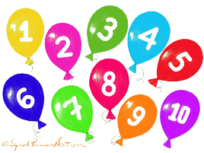  Play a game of “Making 10” Go-Fish with your family. | Counting By 2s!  Review skip counting by 2s  https://www.youtube.com/ watch?v=GvTcpfSnOMQ  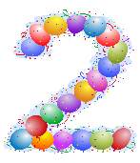  Then, gather a set of 20 items. Practice skip counting the items by 2s.  This Photo by Unknown Author is licensed under CC BY-NC
Guess My Number!  Practice counting backwards from 20-1.  https://www.youtube.com/ watch?v=srPktd4k_O8  Then, have a helper give you clues on a number between 1-20 that they are thinking about. Clues could include; the number is 1/2 more than____, the number is 1/2 less than than ____.  This Photo by Unknown Author is licensed under CC BY-ND | 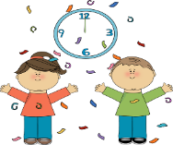  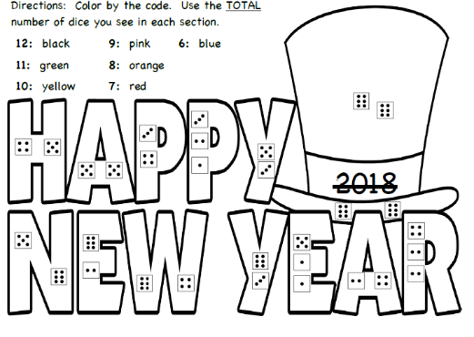  Happy New Year!  This Photo by Unknown Author is licensed under CC BY-SA-NC  *Activity will be included in learning pack. | Game Time  Play a board game with someone.  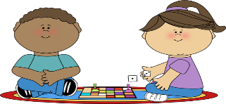  This Photo by Unknown Author is licensed under CC BY-SA-NC
*Choose 1 activity each day to complete. When we return to school, I will be looking to see what activities you chose.

