Grade 2 Writing Choice Board
*Choose 1 writing activity each day to complete. Once you’ve completed your writing piece, edit your work using the Writing Checklist. When we return to school, I will be looking to see what activities you chose. Also, don’t forget to read one of your Good Fit Books!
Finish The Sentence  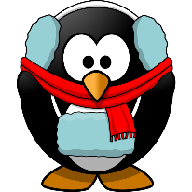  If I were a penguin I would… (Include some details!) | Making A Connection  Watch this read aloud:  https://www.youtube.com/ watch?v=stpRJcf7QTI  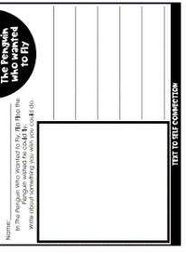  Then, complete this writing task.  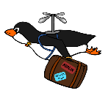 | What would you rather?  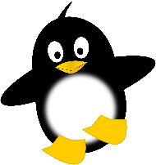  Would you rather make friends with a wild polar bear or a crazy penguin? Why?  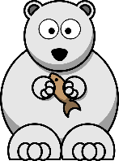
Penguin Reading Response  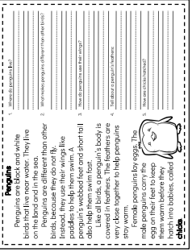  Read the story, then answer the comprehension questions. Please answer questions in sentence form. Ex. Penguins live both on land and in the sea.  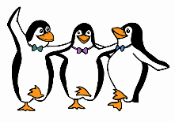 | My Pet Penguin  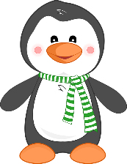  Imagine you’ve been given a pet penguin to take care of. How would you do that? What would you feed him? Where would he sleep? | The Emperor’s Egg!  Watch this read aloud:  https://www.youtube.com/ watch?v=uJzOpnBzCgk&t=9s  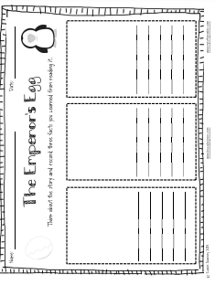  Then, complete the following writing task.  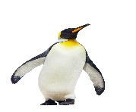  This Photo by Unknown Author is licensed under CC BY-NC

