Grade 1 Math Choice Board
Penguin Double Cover Up  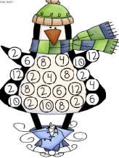  This game will help you practice your double facts to 12. Directions on how to play are included in your learning pack. | Penguin Subitizing  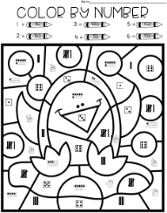  Subitize (look and tell how many without counting), then color according to the code given at the top. | Penguin Roll, Add and Color  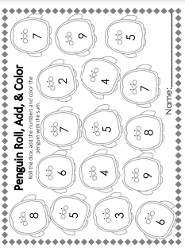  Practice counting on from the biggest number.
Penguin Patterning  Color the penguins scarves according to the letter code given in each row. I’ve done the first one for you as a review!  This Photo by Unknown Author is licensed under CC BY-SA | Game Time  Play a board game with someone. | Counting By 2s!  Review skip counting by 2s  https://www.youtube.com/ watch?v=GvTcpfSnOMQ  Then, count to by 2s to help the penguin reach his ice cream.
*Choose 1 activity each day to complete. When we return to school, I will be looking to see what activities you chose.

