Grade 2 Writing Choice Board
Snowman At Night  Watch this read aloud:  https://www.youtube.com/ watch?v=Fh94l1qovF8  Finish The Sentence  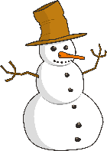  If I were a snowman at night…(Don’t forget to add some details. Where would you go? What would you do?) | What would you rather?  Would you rather build a snowman or make a snow angel? Why?  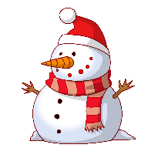 | Reading Response  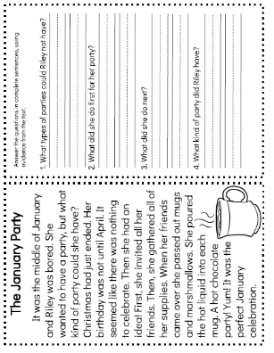  Read the story, then answer the comprehension questions. Please answer questions in sentence form. Ex. Riley could not have a Christmas or birthday party.  * Included in learning pack!
Snowball Fight  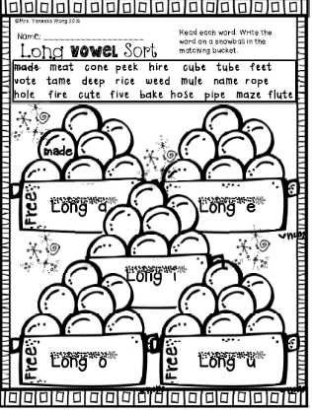  * Included in learning pack!  This Photo by Unknown Author is licensed under CC BY-NC-ND | Sneezy’s Friends  Watch this read aloud:  https://www.youtube.com/ watch?v=iUsHnKSyDH0  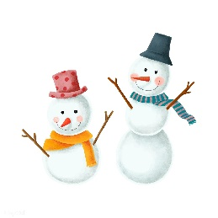  Then, write about a time that you’ve helped a friend out. | Do You Want To Build A Snowman?  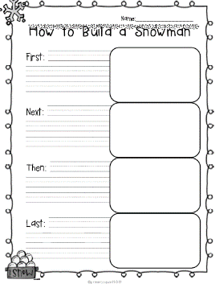  * Included in learning pack!  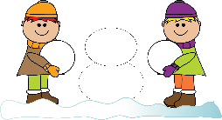
*Choose 1 writing activity each day to complete. Once you’ve completed your writing piece,edit your work using the Writing Checklist. When we return to school, I will be looking to see what activities you chose. Also, don’t forget to read one of your Good Fit Books!

