APRIL 17th-21st
Letters of the week-- Celebrating A-Z letter sounds and formation
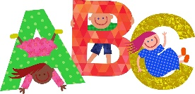
Words of the week-- can come
April is Poetry Month! The kids are having fun listening to and writing poems!
I encourage you to read/discuss lots of poetry this month- Nursery Rhymes are a great place to begin… expand from Nursery Rhymes to other poetry for children- find play in poems, clap the beat etc…
Mrs. Robichaud comes for Guidance each Tuesday (Social and Emotional Health)

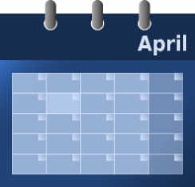
Themes for April – Poetry and Nursery Rhymes, Dental Awareness Month, Easter, Exploring Color, Weather, Earth Day , , ,
5-2-1-0 – Tip of the week – LESSEN screen time, go outdoors instead

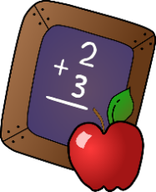
MATH- Always working on n Numeracy Skills: from #’s 1-10
One to one correspondence when counting (Touch/count)
Counting begins with 1 and there is a set sequence
last number said is the amount in the set
The starting point and order of counting does not affect the quantity (irrelevant order)
The arrangement or types of pictures or objects do not affect the count
It does not matter what is being counted, the result will not change
Counting on…adding On

