APRIL 3-6
Letters of the week-- Yy and Zz will finish this week
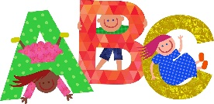
Words of the week-- this
April is Poetry Month! I encourage you to read/discuss lots of poetry this month- Nursery Rhymes are a great place to begin…
Mrs. Robichaud comes for Guidance each Tuesday (Social and Emotional Health)
Thursday- Everything EGGS- our theme for our last day

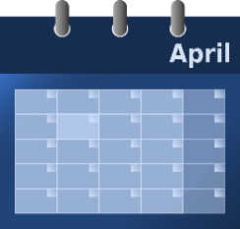
Themes for April – Poetry and Nursery Rhymes, Dental Awareness Month, Easter, Exploring Color, Weather, Earth Day , , , 5-2-1-0 Kick off

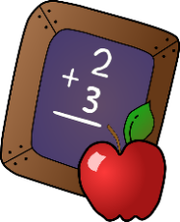
MATH- Working on Numeracy Skills: 1-10
One to one correspondence when counting
Counting begins with 1 and there is a set sequence
The last number said is the amount in the set
MATH

The starting point and order of counting does not affect the quantity (irrelevant order)
The arrangement or types of pictures or objectsdo not affect the count
It does not matter what is being counted, the result will not change
Counting on…adding On

