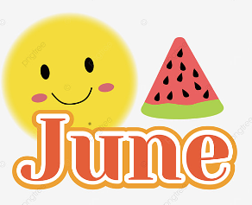
A Peek At Our Week!
May 29th -June 2nd

This week in Language Arts we continued to work on phonemic awareness activities (understanding that words are made up of individual sounds) with emphasis on reviewing short and long vowel sounds and segmenting and blending three phoneme words. During writing time, students worked on writing their fictional stories.

In Math, Grade 1 students worked on solving missing part word problems using either hands-on materials or drawing a picture and recording the number sentence. Grade 2 students worked on solving two-digit addition and subtraction number stories with and without regrouping.

During exploratory time this week we had several visitors once again. Students from JMH came on Tuesday and Thursday. This week we played a game reviewing what we’ve learned during their time with us, and our weekly visits ended with the girls teaching a dance that they created. We also had a Roots of Empathy session. We are wrapping up the program, so this week was devoted to getting some final projects done to present to Baby Aidan at our celebration next week. We ended the week with a few ladies from Public Health coming to share a book that has been created reviewing 5210 daily goals (5 fruits and vegetables, no more than 2 hours of screen time, at least 1 hour of physical activity, and 0 sugary drinks).

Enjoy your weekend!

