A Peek at our Week!
Please NOTE: There will be no school Thursday and Friday May 4 and 5
Exploration: Dental Awareness Month cont’d
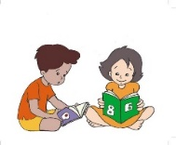 Language Arts 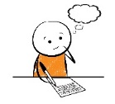
- Letters of the week – Alphabet sounds and letters review
- Words of the week – that and this
- Reading – Cross Check- look into the word to see if it matches the pictue, and are the letters you would expect in the word? letters/sounds, Retelling important events in sequence Beginning/Middle/End , Characters and Setting (who? Where? What happened?)
- Writing- basic repeating pattern sentences to practice sight and high frequency words
high frequency words these are words most encountered in early reading and writing.
Sight words – these are words that students should know by sight… often irregular in spelling
so they free thinking space for working out new words…
PRACTICE READING EACH NIGHT

Math This Term
NUMBERS- Present Unit- Shape and Space= 2d and 3d shapes and objects
~ naming “basic shapes- square, rectangle, triangle, circle and some others-
~ naming and identifying attributes of 3d shapes-ball, cone, box, pyramid, cone
Count forward and back to and from 10 from any number, name the numbers before and after various numbers,
- Subitizing -Recognizing at a glance familiar arrangements of dots and other items (number cubes, fingers, 5 frames etc)
- Relate a numeral to its quantity 1-10
- Compare quantities 6-10 using 1-1 correspondence, Showing a quantity in 2 parts
- Represent and Describe numbers 2-10 concretely and pictorially
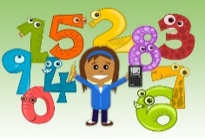
ART- we want to Thank Adam Barry for presenting an art lesson on drawing using the basic element of art SHAPES. . . the children enjoyed it and producing their own examples .

