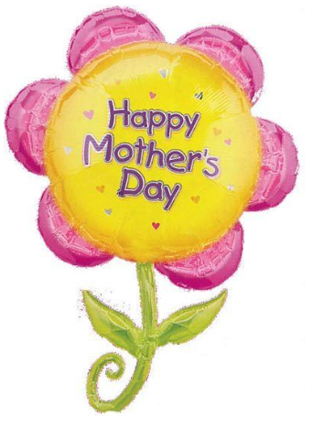
A Peek At Our Week!
May 8th–12th

This week in Language Arts we continued to work on phonemic awareness activities (understanding that words are made up of individual sounds) with emphasis on reviewing short vowel sounds and segmenting and blending words. During writing time students wrote List poems.

In Math, Grade 1 students worked on solving subtraction word problems using either hands-on materials or drawing a picture and recording the number sentence. As well, they practiced counting by 2’s to 20 again. Grade 2 students worked on solving two-digit addition number sentences with and without regrouping. They also reviewed skip counting by twos beginning at different multiples of twos.

During exploratory time this week we had several visitors. Students from JMH came a couple of times to teach us about healthy lifestyle practices. This week we learned a few different stretches and ended our time together by dancing away to stretch our bodies. We ended the week with a visit from Baby Aidan and his mom.

A few reminders:
-Jump Rope for Heart Fundraiser began on Monday. The fundraiser will run until next Friday, May 19th. Once your fundraising is complete, feel free to return the envelope.
-Don’t forget about our 5210 Energy Cube Challenge.

Happy Mother’s Day Moms. Enjoy your weekend!

