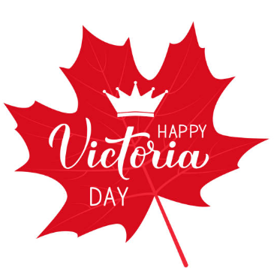
A Peek At Our Week!
May 15th -19th

This week in Language Arts we continued to work on phonemic awareness activities (understanding that words are made up of individual sounds) with emphasis on reviewing short vowel sounds and segmenting and blending words. During writing time, we worked together to write a fictional story.

In Math, Grade 1 students worked on solving subtraction word problems using either hands-on materials or drawing a picture and recording the number sentence. As well, they practiced reading number words. Grade 2 students worked on solving two-digit subtraction number sentences without regrouping.

During exploratory time this week we had several visitors once again. Students from JMH came on Tuesday and Thursday. This week we reviewed the importance of personal hygiene and healthy eating. We also had two Roots of Empathy sessions. We finished the theme communication and then began discussing what makes us special. We ended our week with the whole school participating in the Jump for Heart event. Fun was had by all!

A few reminders:
_No school on Monday!
-Don’t forget about our 5210 Energy Cube Challenge.
Enjoy your long weekend!

