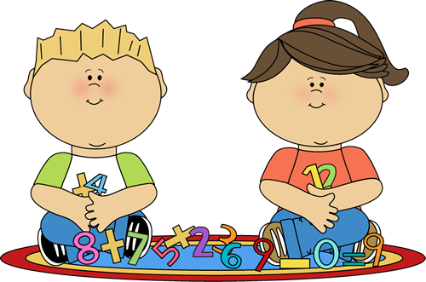
A Peek At Our Week!
This Photo by Unknown Author is licensed under CC BY
May 23rd-26th

This week in Language Arts we continued to work on phonemic awareness activities (understanding that words are made up of individual sounds) with emphasis on reviewing long vowel sounds, segmenting and blending words. We also talked about the ending “ed” and learned that it can make three different sounds. During Writer’s Workshop, students worked on planning their own fictional story.

In Math, Grade 1 students worked on solving missing part addition word problems using either hands-on materials or drawing a picture. Grade 2 students worked on solving two-digit subtraction number sentences with regrouping.

During exploratory time this week we had several visitors once again. Students from JMH came on Tuesday and Thursday. This week we reviewed the importance of moving our bodies. As well, Baby Aidan and his mom came to visit us. It has been fun to watch him grow!

Enjoy your weekend!

