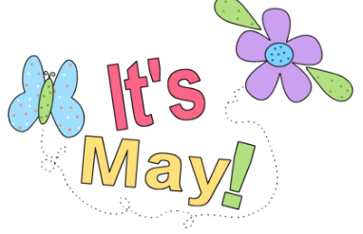
A Peek At Our Week!
May 1st-3rd

This week in Language Arts we continued to work on phonemic awareness activities (understanding that words are made up of individual sounds) with emphasis on reviewing short vowel sounds and segmenting and blending words. During writing time students wrote an “I Wish” poem.

In Math, Grade 1 students worked on representing numbers in a variety of equal groups with and without singles. As well, they practiced counting by 2’s to 20. Grade 2 students worked on measuring length using non-standard units. They also reviewed counting coins (quarters, dimes, and nickels).

Exploratory time this week was devoted to the Roots of Empathy program to attempt to get caught up on sessions missed while I was absent.

A few reminders:
-Jump Rope for Heart Fundraiser begins on Monday, May 8th and will run until Friday, May 19th . Pledge sheets will be sent home on Monday.
-Keep working on your 5210 Energy Cube Challenge. Don’t forget to record your activity in your log book.

Happy Long Weekend Everyone!

