November 17, 2023

What’s up prof?
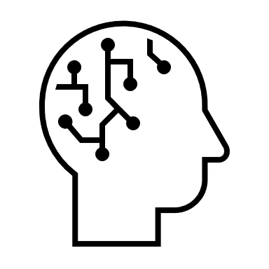
Math: We are currently looking at fractions. We will revisit one step equations with a variable and practice the measures of lengths. This week and next week, tests will be administered as it is the end of term 1.
Art: We do different art projects every week. We are working on art projects related to the paintings of the impressionists and post impressionists.
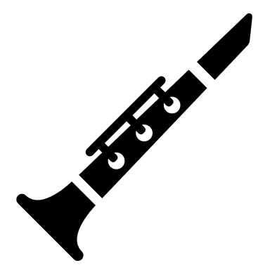
Music: We are learning the recorder flute notes and some easy songs. We are practicing a tune and a song for the Christmas concert.
French: We have finished the unit on sports (our pass-times) and started the unit on music. We are also doing a variety of activities related to the theme we are working on. The assessment in French is done through the different activities we are doing in class, orally and in a written form.

Mr. LeBlanc

