November 2, 2023

What’s up prof?

Math: We are still working on basic multiplications and divisions. Next will be the fractions, solving one step equations with a variable.
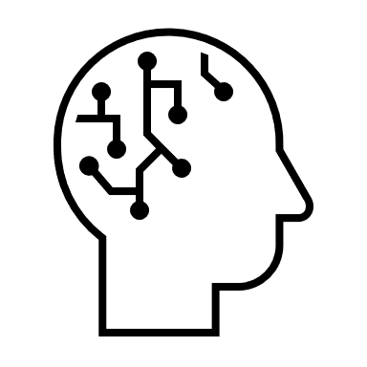
Art: We do different art projects every week.
Music: We are learning the recorder flute notes and some easy songs.
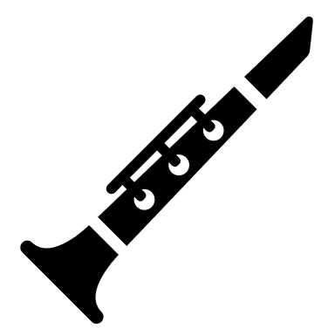
French: Following the Intensive French program, we are working on learning about pass-times, sports, and the next unit will be on music. We are also doing a variety of activities related to the theme we are working on.
Mr. LeBlanc

