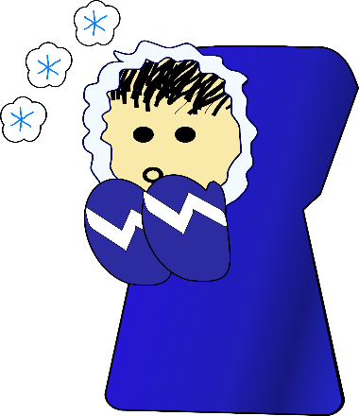
What We’ve Been Up To!
November 27th

In Language Arts we have continued to work on phonemic awareness activities (understanding that words are made up of individual sounds) with emphasis on rhyming, identifying beginning and ending sounds in multiple words, segmenting and blending onset-rime in words (ex. b-at), and reviewing letter names and sounds. During small group reading instruction, students worked on decoding words with short vowels and words with digraphs (th, sh, & ch). In writing, students completed a small moment story. The focus was on, adding details, and stretching unknown words and recording sounds heard.

In Math, Grade 1 students worked on skip counting by 2s to 20. Grade 2 students worked on skip-counting by 5s forward to 100 beginning at different multiples of 5.

Discussing “rights and responsibilities” was the focus of our Exploratory time over the last few weeks. We also had a couple of Roots of Empathy sessions, one included a visit from Baby Annie.

A few reminders:
-Skating at LBA~ Thursday, November 30th between 9:00-10:00
~Report Cards Go Home~Monday, December 4th
~Parent Teacher Interviews~Thursday, December 7th (pm) and Friday, December 8th (am)

If any time you have any questions or concerns, please don’t hesitate to reach out. You can reach me either by phone (778-6080) or by email (jodi.sobey@nbed.nb.ca)!

