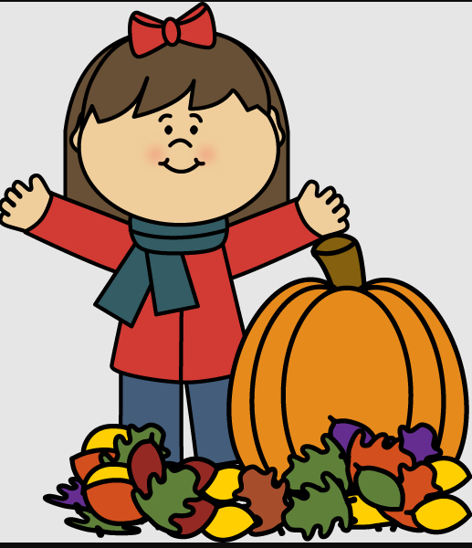
What We’ve Been Up To!
October 16th

In Language Arts we have been working on phonemic awareness activities (understanding that words are made up of individual sounds) with emphasis on rhyming, segmenting, and blending two syllable words, and reviewing letter names and sounds. During writing time, we’ve been working on choosing an idea quickly, using proper spacing between words and stretching unknown words and recording sounds heard.

In Math, Grade 1 students recently wrapped up a unit on repeating patterns and over the last week they have been working on counting forwards and backwards from 20 starting and ending at different numbers. Grade 2 students have been working on identifying, creating and extending increasing/growing patterns.

In recent weeks during Exploratory time, we’ve learned about Fire Safety at home and school, and we’ve discussed being thankful and showing gratitude. As well, we have had a few sessions of Roots of Empathy. Baby Annie has come once to visit us. Her visit was by far one of our favorites things that has happened over the last few weeks. She comes again this week!

A few reminders:
_October 30th Orange and Black Day
-October 31st Costumes and Pumpkin Carving

If any time you have any questions or concerns, please don’t hesitate to reach out. You can reach me either by phone (778-6080) or by email (jodi.sobey@nbed.nb.ca)!

