WELCOME TO MY TEACHER PAGE!
Here you will find our review of lessons and reminders for special events or requirements, Or sometimes more immediate memos and what is up and coming!. OUR CURRENT THEMES~ Hibernation and Winter/Snow
****We have a guest, Mr. Hayward, coming on Mondays to work with Kindergarten students on photography which will be integrated into L.A and Math!
Language Arts: Phonemic Awareness Activities.

Listening to sounds through games and poems to activate listening skills that will eventually lead to listening for sounds in words
Daily drills focus on how letters and words work; initial, medial (long and short vowels) and ending sounds. Chopping and blending 3 and 4 sounds in words; learning initial and final diagraphs (2 letters 1 sound (sh, ch, th) and some blends
Reading-Daily routines such as our morning letter teach reading and writing concepts; directionality, 1-1 word match, return sweep, and introduce high frequency words: Students will be taking a practice book home a few nights/week
Poetry Anthology- Familiar songs and poems to help reinforce the above and foster a love for words and reading, and independence
Writing- ABC BOOM!- students learn different strokes that form letters or combine to make letters. Watch folders for current practice.
To Date- PLOP! THE CAVE snore!, the car VROOM!, BOING! Toboganners 1 & 2 WEEEE Climber UUUP. Pinwheel
Journals-students frequently discuss and do some writing of their stories through drawings and early attempts at print.
Letter and word practice in their booklets will begin
Zoo Phonics- 26 animals live in the ZOO, each representing the alphabet. Activities focus on individual letters and sounds and ARTICULATION, which assist in reading and written work. ANIMALS of the week ~ we have met and explored initial letters for Sammy Snake, Timothy Tiger, Umber Umbrella Bird, Vincent Vampire bat, Willie Weasel and Xavier Fox, Yancy Yak and Zeke Zebra!

This Photo by Unknown Author is licensed under CC BY-NC
MATH
Present Outcomes – Please note that with the various outcomes we work on through the year. First numbers 0-5 and now we are working on 6-10
*Numbers to 1-10 -– Subitizing – I know how many without counting! Fingers, familiar arrangements of dots (Dice), 5 Frames, Numbers before and after, Showing number amounts in a variety of ways and Counting in different ways to and from various numbers
Patterns- always revisited -identify, copy, extend, create, describe, and name the CORE of patterns! We use Actions, Sounds, and small materials to carry out tasks. Patterns of more complexity- AAB, ABB, AABB, ABC, ABCD.
Exploratory-
Our multiage class has been busy with various lessons about special Calendar events, Earth Day and Habitats which Transfer into music and art
7 Sacred Teachings :
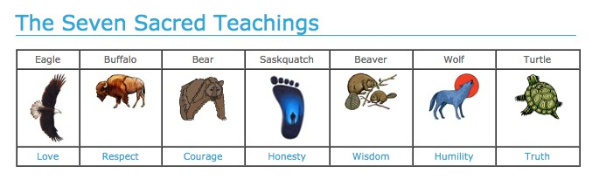
We have completed the 7 Indigenous teachings and learned lots! Our school is home to our “Spirit Bear” and with our classroom bears have been hibernating, but we expect them to wake VERY soon!
Roots Of Empathy: the students have been engaged in this wonderful program which through monthly visits of Baby Annie the students learn about and discuss the growth of others.

