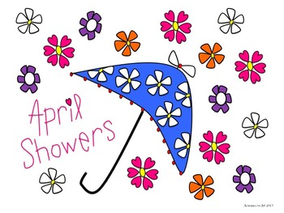
What We’ve Been Up To!
April 26th

In Language Arts we have continued to work on phonemic awareness activities (understanding that words are made up of individual sounds) with emphasis on identifying short and long vowels sounds in words, segmenting and blending words with four phonemes (sounds), changing and deleting final sounds in words, reviewing letter names and sounds, diagraphs (th, sh, ch, why), and “l” and “r” blends. Segmenting and recording sounds heard in four phoneme (sound) words continued to be practiced. Over the last few weeks, we worked together to write a made-up story. The main writing focus continued to be on stretching words and recording all sounds heard, as well we worked on including details to make our story more interesting.
In Math the Grade 1’s students have begun to solve addition and subtracting word problems using pictures or hands-on materials and recording the number sentence. Grade 2 have been learning how to solve double digit addition and subtraction number sentences with answers to 100 using hands-on materials.
Exploratory time recently was devoted to understanding and practicing personal safety skills (appropriate and inappropriate touches). As well, we discussed ways to care and protect our environment.

A few reminders:
~Wednesday, May 1st, Dr. Losier Play (We are leaving the school at 8:30 and will be returning a little after 10:30)
~No School for students on Thursday, May 2nd and Friday, May 3rd.

If any time you have any questions or concerns, please don’t hesitate to reach out. You can reach me either by phone (778-6080) or by email (jodi.sobey@nbed.nb.ca)! ~

