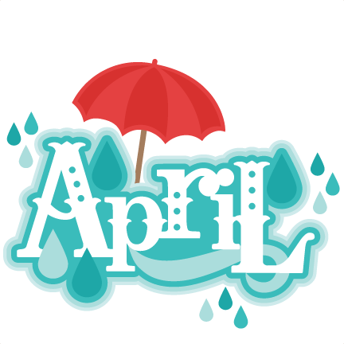
What We’ve Been Up To!
April 5th

In Language Arts we have continued to work on phonemic awareness activities (understanding that words are made up of individual sounds) with emphasis on identifying short vowels sounds in words, segmenting and blending words with four phonemes (sounds), changing and deleting initial sounds in words, reviewing vowel names and sounds, diagraphs (th, sh, ch), “l” blends and we’ve begun to review “r” blends. Blending and reading four phoneme (sound) words continued to be practiced. Over the last few weeks students worked on writing a small moment story and they also completed an Easter “How-tO” piece. The main writing focus continued to be on stretching words and recording all sounds heard, with extra emphasis on ensuring that at least one vowel has been included in every word. As well, students worked on adding details to expand their ideas.
In Math Grade 1’s completed a unit on replicating 2D and 3D objects and comparing 2D shapes to parts of 3D objects found in our classroom. Grade 2 students completed a unit on showing the meaning of place value (groups of tens and ones) to 100 by drawing pictures and using manipulatives.
Exploratory time recently has been devoted to preparing for the historic Solar Eclipse that will happen on Monday, April 8th.

A few reminders:
~Students will be dismissed at 11:30 a.m. on Monday, April 8th
~Report Card Day will be Wednesday, April 10th
~Parent Teacher Interview will be held on April 15th, both in the morning and again in the evening. No school for students.

If any time you have any questions or concerns, please don’t hesitate to reach out. You can reach me either by phone (778-6080) or by email (jodi.sobey@nbed.nb.ca)! ~

