February 26, 2024

What’s up prof?
English: English language art is divided in parts, including reading, talking and listening. We will explore different styles of writing and analyze them to develop an understanding of the language. There will be oral presentations, essays, reading time, research on different topics, etc.…

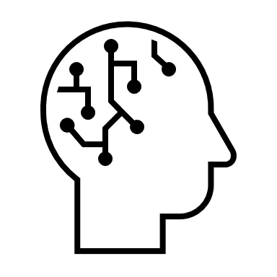
Math: We are currently working on divisions of a three-digit number by a single digit number. We also are looking at big numbers to one million and their use.
Art: We do different art projects every week. We are working on art projects related to pop art and op art.

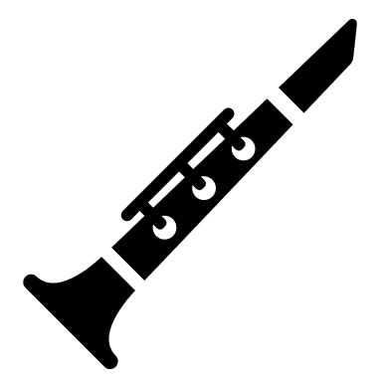
Music: We are learning the recorder flute notes and some easy songs. We will practice a selection of songs. We also work on musicplayonline at times. We will work also with the ukulele eventually.
French: We have finished the intensive French part of the year. We still have French lessons 30 minutes a day. The unit we are working on is about domestic animals and pets.

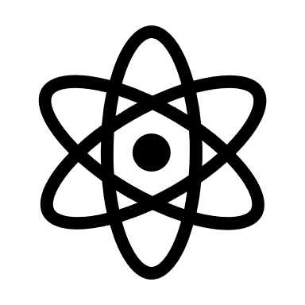
Science: We explore the human body and its different systems. We finished the four first systems of the body and are going to look at the muscular system, the bones and the reproductive system.
Social Studies: We look at different societies of the past and how they shaped our world. We are looking at how we can know about the past. We will also study the different periods of human history.
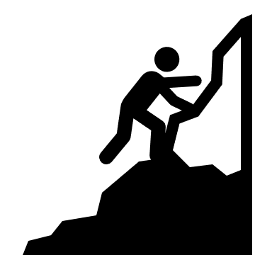
Health: We look at health as a result of our good healthy choices. We finished the food guidelines and are now looking at healthy lifestyle including screen time and sleep.

Mr. LeBlanc

