January 30, 2024

What’s up prof?
English: English language art is divided in parts, including reading, talking and listening. We will explore different styles of writing and analyze them to develop an understanding of the language. There will be oral presentations, essays, reading time, research on different topics, etc.…

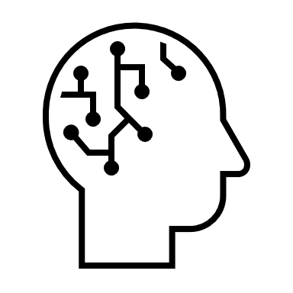
Math: We are currently working on multiplications of a one- or two-digit number by a two or three-digit number. The next step will be divisions.
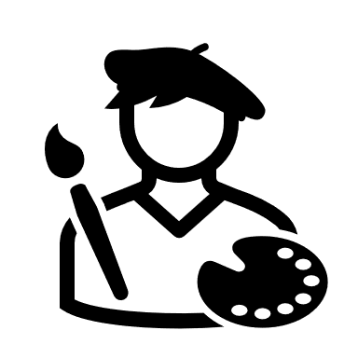
Art: We do different art projects every week. We are working on art projects related to pop art and op art.

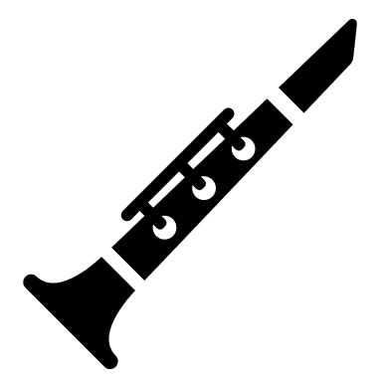
Music: We are learning the recorder flute notes and some easy songs. We will practice a selection of songs. We also work on musicplayonline at times. We will work also with the ukulele eventually.
French: We have finished the intensive French part of the year. We still have French lessons 30 minutes a day. The unit we are working on is about animals.

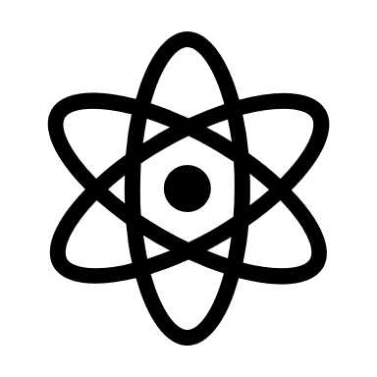
Science: We explore the human body and its different systems.
Social Studies: We look at different societies of the past and how they shaped our world.
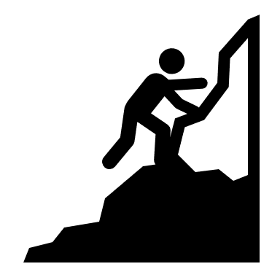
Health: We look at health as a result of our good healthy choices.

Mr. LeBlanc

