WELCOME TO MY TEACHER PAGE!
Here you will find our review of lessons and reminders for special events or requirements, Or sometimes more immediate memos and what is up and coming!. OUR CURRENT THEMES~ Hibernation and Winter/Snow
*Monday – Mr. Hayward visits (when possible)
*Tuesday ` Hot Lunch Day
*Thursday~ 100th Day Of School! (weather Permitting ) get your tshirt ready!
****
Language Arts: Phonemic Awareness Activities .

Listening to sounds through games and poems to activate listening skills that will eventually lead to listening for sounds in words
Daily drills focus on how letters and words work; initial, medial (long and short vowels) and ending sounds. Chopping words into sounds (consonant/vowel/consonant) and blending sounds.

Reading-Daily routines such as our morning letter teach reading and writing concepts; directionality, 1-1 word match, return sweep, and introduce high frequency words: Students will be taking a practice book home a few nights/week
Poetry Anthology- Familiar songs and poems to help reinforce the above and foster a love for words and reading, and independence
Writing- ABC BOOM!- students learn different strokes that form letters or combine to make letters. Watch folders for current practice.
To Date- PLOP! THE CAVE snore!, the car VROOM!, BOING! Toboganners 1 & 2 WEEEE Climber UUUP!
Journals-students frequently discuss and do some writing of their stories through drawings and early attempts at print.
Letter and word practice in their booklets will begin this week
Zoo Phonics- 26 animals live in the ZOO, each representing the alphabet. Activities focus on individual letters and sounds and ARTICULATION, which assist in reading and written work. ANIMALS of the week ~ Kayo Kangaroo and Lizzy Lizard (we got stalled here) oops sorry.

MATH
This Photo by Unknown Author is licensed under CC BY-NC
Present Outcomes – Please note that a handout was sent home last week with the various outcomes we work on through the year. First numbers 0-5 and now we are working on 6-10
Numbers to 6-10 -– Subitizing – I know how many without counting! Fingers, familiar arrangements of dots (Dice), 5 Frames, Numbers before and after, Showing number amounts in a variety of ways and Counting in different ways
Patterns- always revisited -
I can identify, copy, extend, create, describe, and name the CORE of patterns! We use Actions, Sounds, and small materials to carry out tasks. Patterns of more complexity- AAB,ABB, AABB, ABC, ABCD.
Exploratory-

Our multiage class has been busy with various lessons about Hibernation, Migration and Adaptation which Transfer into music and art
Rachel Bell is leading us in our Indigenous teachings and we are learning lots! Our school is home to our Spirit Bear and we made a Den during Art.
We’ve begun exploring the 7 Sacred Teachings trying to introduce 1/week~
#1 LOVE~ represented by the Eagle

#2 WISDOM~ represented by the Beaver
This Photo by Unknown Author is licensed under CC BY-NC
#3 RESPECT~ Represented by the Bison
#4 HONESTY - Represented by The Sabii (Big Foot)
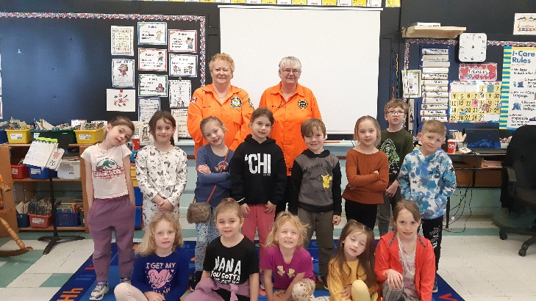
Thank You MIRAMICHI GROUND SEARCH and RESCUE for the Hug A Tree Presentation and Safety Kit.

