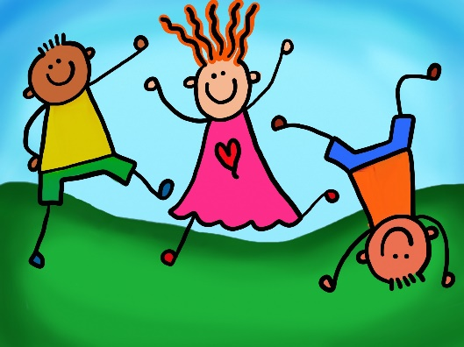
What We’ve Been Up To!
June 1st!

In Language Arts we have continued to work on phonemic awareness activities (understanding that words are made up of individual sounds) with emphasis on segmenting and blending words with four phonemes (sounds), identifying vowels sounds in words, adding and deleting final sounds in words, changing vowel sounds in words and reviewing letter names and sounds, diagraphs (th, sh, ch, wh), and “l” and “r” blends. Segmenting and recording sounds heard in four phoneme (sound) words continued to be practiced. We also spent time learning what r-controlled “or/ore” and “er” says. Over the last few weeks students have been working on writing a fictional piece of writing. Our writing focus has been on using proper capitalization throughout their stories.
In Math the Grade 1’s students worked on solving addition and subtraction comparison (more/fewer) word problems using pictures or hands-on materials and recording the number sentence. Grade 2 worked on solving double digit addition and subtraction word problems with answers to 100 that included regrouping using hands-on materials.
Exploratory time recently was devoted to discussing the importance of including “joyful movement” into our daily routine to help us have heathy hearts and bodies. As well, we spent time exploring water and it’s benefits for our bodies and our earth.

If any time you have any questions or concerns, please don’t hesitate to reach out. You can reach me either by phone (778-6080) or by email (jodi.sobey@nbed.nb.ca)!

