Grade 4 Math Home Learning Math Warmups

17  What time is it right now? What time will it be in 20 minutes? What time will it be in 12 minutes? | 18  Ms. Brown had 217 flowers. She put the same number of flowers in each of 9 vases. How many flowers were in each vase? Did she have any flowers left over? | 19  What time is it right now? What time will it be in 60 minutes? What time will it be in 2 hours and 10 minutes?  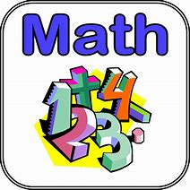 | 20  Farmer Brown has pigs and chickens. How many of each could he have if there are 28 legs? | 21  Play a game of Multiplication War. For each turn, each player flips over 2 cards and finds the product. The greater product wins the cards.
24  Roll 2 dice. Multiply to find the product.  Is the product odd or even?  How do you know? | 25  Predict how many times you can write your name in 1 minute. Try it. | 26  Play a game of How Many more? For each turn, turn over a card and tell how many more to make 10. Then try how many more to make 20. | 27  Think of a story problem you could solve with this equation:  5 x 6 = __.  Tell the answer. | 28  Which has more tires: 15 tricycles or 12 cars? How do you know?  