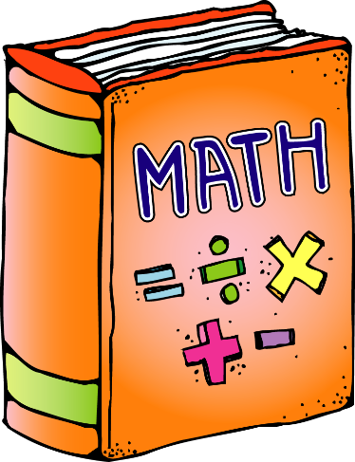

**Math Workshop**

**Warm up:**

Riddle:

I am an even number.

My ones digit is the number of wheels on 3 bikes.

I am between 50 and 60.

What number am I?

**Math Game:**

Using the deck of cards that were sent home in November, play “how many more?”. Use the cards from the Ace to 9. Have a parent or guardian show you a card from the deck and you must tell them how many more to make 10!

You can also include the 10 card and play to how many more to 15? and how many more to 20?

**Technology:**

Work on SplashLearn.com. I put lots of assignments to review of addition, subtraction, and multiplication. 😊