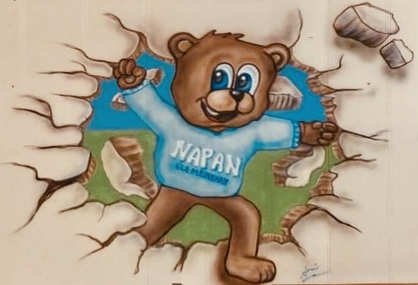 Napan Elementary School
225 South Napan Road
Napan, NB E1N 4W2
Phone: (506) 778-6080 Fax: (506) 778-6541
Principal: Ms. Barbara Brown

October 21st, 2024

Dear Parents/Guardians,

There will be skating for Napan Elementary students Grades K - 5 at the LBA, starting on November 7th from 9:00 am to 10:00 am. Students will travel by bus from the school.
Helmets must be worn by all students. Out of concern for our students, we strongly recommend that all children wear gloves or mittens to prevent accidents if someone falls. Fingers can be seriously cut by skate blades.
Grades K-2 need ski pants to wear.
Students may bring a water bottle only.
Volunteers to help tie skates are welcome.
LBA requires anyone on the ice surface, including Parent volunteers to wear skates.
Please keep in mind that this is a physical education activity. Students are expected to participate and remain on the ice until dismissed. If they need a rest, there is an area assigned. Please do not take your child off of the ice prior to the teacher’s instructions.
If school is cancelled on a scheduled skating day, skating will not be rescheduled.
Following are the dates for skating:
Thursday, November 7th
Thursday, November 21st
Thursday, December 5th
Thursday, December 19th
More dates will follow for January.

Please take note of the Public Skating rules posted by the City of Miramichi on the back.

