Grade 1 Math Choice Board
Friends of 10  Make a list of friends of 10.  e.g. 9’s friend is 1  2’s friend is 8  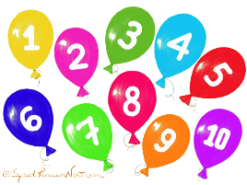 | Game Time  Play a board game with someone.  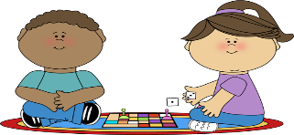  This Photo by Unknown Author is licensed under CC BY-SA-NC | Doubles Fun  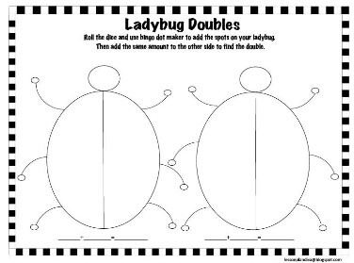  Roll a number cube. Create a ladybug to show the double fact!
Shape Creation  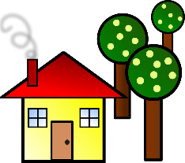  Draw a building using squares, circles, triangles, and rectangles. Record how many of each shape you used. | Counting Backwards  Count backwards from…  19 - 6  11-2  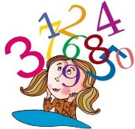  Record the numerals on paper. (e.g. 14, 13, 12, 11, 10, 9 )  This Photo by Unknown Author is licensed under CC BY-NC | Patterning  Make an ABBC pattern with items from your house. Either draw a picture to show me or snap a picture and email me. jodi.sobey@nbed.nb.ca
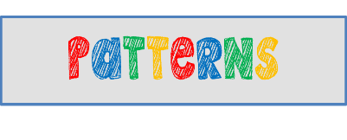
*Choose 1 activity each day to complete. When we return to show I will be looking to see what activities you chose.
This Photo by Unknown Author is licensed under CC BY-NC-ND

