November 10, 2021

Good morning!
I hope you are all doing great! Tomorrow is Remembrance Day. I know that you and your family will take a moment to think about the veterans. We know that it is because of what they did that we have a wonderful life here in Canada.

- Reading: you have some new books to read from your package. You can choose Read to Self or Read to Someone. Or even both!
Here is a special poem that you can read for Remembrance Day. Read it a few times and make sure you share it with your family.

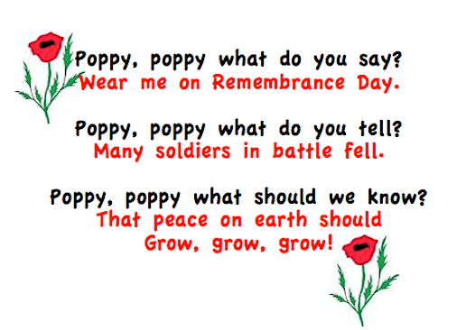

- Listen to Reading using this link. It is the story “The Soldier’s Puppy”.
https://www.youtube.com/watch?v=IZYSNLWwhlE
- Writing: in your new packet you have a writing sheet called “You are my Hero”. You are to write a letter to a veteran. Think about the Remembrance Day stories and how brave the soldiers were during the wars. Think about the wonderful life that you have living in Canada and how grateful you are for that! Think about how important it is to be kind to others and how much we enjoy being peaceful. Think about wearing a poppy and what that means.
- Complete one of the “Color the Rhyme” sheets.
- https://www.youtube.com/watch?v=nAUdQZ8Xivw
A link to another fun video and song to help up learn more rhyming words.

Have a great day!

