November 12, 2021
Good morning,
I hope you had a nice day yesterday with your families and took a moment to remember those that sacrificed so much so we can live in peace!
- Read this fun poem, “Pets”. The pictures will help you with any words you are unsure of! Read it a few times to yourself and then read it to your family and have them join in!

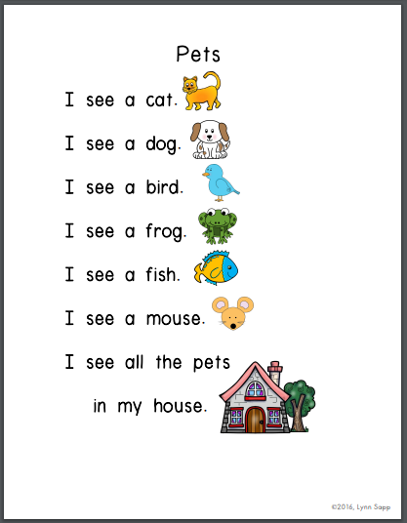

- Read to Self or Read to Someone one of the books from your home learning pack!
- Complete one of your blank writing sheets. You could write about your pet and if you don’t have one you could write about a pet you wish you had!
- Listen to Reading: so many nice stories on storyline online.
www.storylineonline.net

Have a wonderful weekend boys and girls!

