November 8, 2021
Grade 2 Math

- Which One Doesn’t Belong?
Try and come up with reasons for two different leaves that don’t belong!
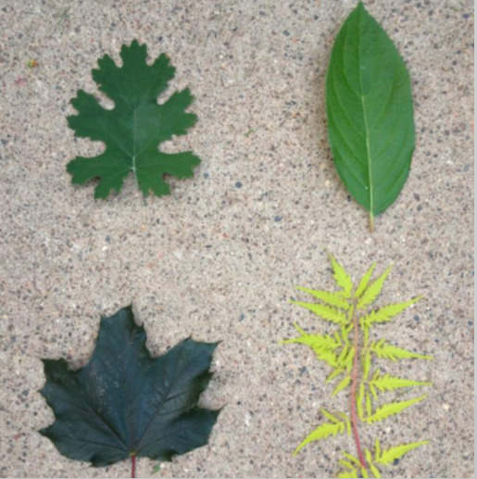

- Logon to Dreambox and play for 20-30 minutes.
- When you get your new learning packet you can complete an activity from it.

