November 10
Good morning!
I hope that you are all well and that you have a wonderful day! We have been so lucky with this beautiful weather! Let’s get outside and enjoy it!

- You have some new math worksheets and games in your learning package. Choose one of those for today and have fun learning!
- Logon to Dreambox and play for 20-30 minutes.
- Try these word problems. Use your 120 chart from your packet to help you if you choose!

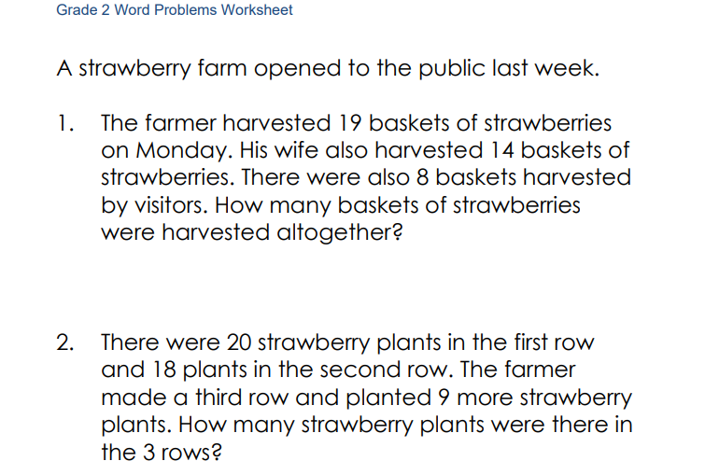
- We did this “Place Value in Nature” activity earlier this fall. I thought you might enjoy showing your family how to do it! Collect some rocks, leaves and sticks. Rocks equal 1, leaves equal 10 and sticks equal 100. See what total you can come up with! For example: 7 rocks, 9 leaves and 5 sticks = 597.

