November 12
Good morning!
I hope that you had a nice day yesterday with your families and were able to take a moment and remember the sacrifice others made so we can live in peace! We have been so lucky with this beautiful weather! Let’s get outside and enjoy it on this beautiful Friday!! Have a wonderful weekend boys and girls!

- You have some new math worksheets and games in your learning package. Choose one of those for today and have fun learning!
- Logon to Dreambox and play for 20-30 minutes.
- Try these new word problems, like the ones you did on Wednesday. Use your 120 chart from your packet to help you if you choose!
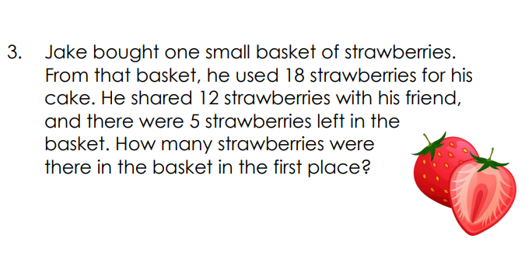

When you are outside today and this weekend, here is a fun scavenger bucket list of items that you can search for! Enjoy!

