Monday, November 29, 2021

Hello boys and girls,
Happy Monday! I hope that you all had a nice weekend! Were you excited to see the snow? It is pretty with the Christmas lights on! I think we will get more snow today too! You should try and get outside and play! Fresh air and exercise are super good for us!
Have a great day and I hope to see you soon!

- This is our poem of the week. You can have your parents read it to you and you can be their echo. Then you can try by yourself!
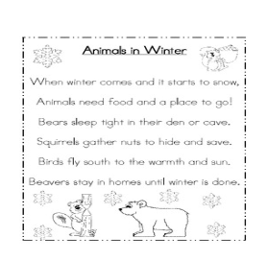
- Read one of the books in your bag to yourself or read it to someone in your family!
- Our words of the week are from the “am” word family. They are: am, ham, jam, swam and the sight word “is”. Write two sentences using one of the words in each.
- Listen to this am word family song/video:
https://www.youtube.com/watch?v=yKrmuy7XVUk

